|  |  |  |
| --- | --- | --- |
| **LAB 321 Assignment** | **Type:** | **Long Assignment** |
| **Code:** | **3** |
| **LOC:** | **200** |
| **Slot(s):** | **12** |

**Title:** Build large calendar

**Background**

**Program Specifications**

Program a web site display list of days as calendar

**Features:**

This website contains following main functions

* Function 1: Display date
  + Display date as a calendar
  + Sunday on red
  + Current day on Green
  + Other on Blue
  + << to go to previous month
  + >> to go to next month
  + == to go to current month

Database description

* Image URL
* Image description

***Expectation of User interface:***

PIC 1 : Calendar

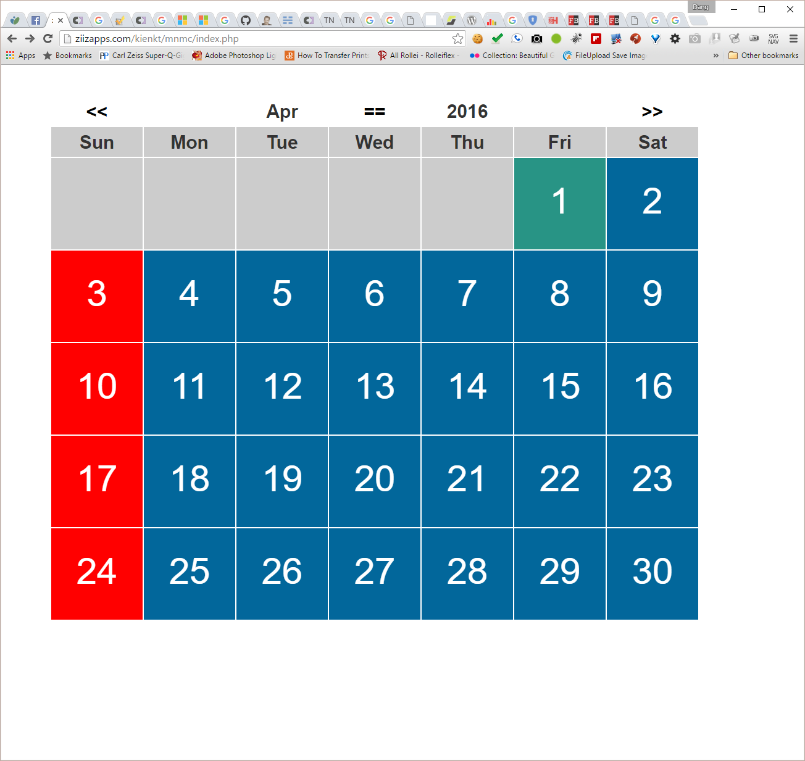

**Guidelines**

* Step 1 : Create web layout
* Step 2 : Create prototype
* Step 3 : Code & Test